Module End Assignment:

“Data Cleaning, Analysis & Visualization with Excel”

1)Data entry, import, and basic organization using tables
Data entry is the process of inputting, updating, and maintaining digital records within computer systems, databases, and spreadsheets.
IMPORT;- Open a blank workbook in ExcelGet Data Import the file.
By using ctrl+a,select the data then press ctrl+t to change into tables.

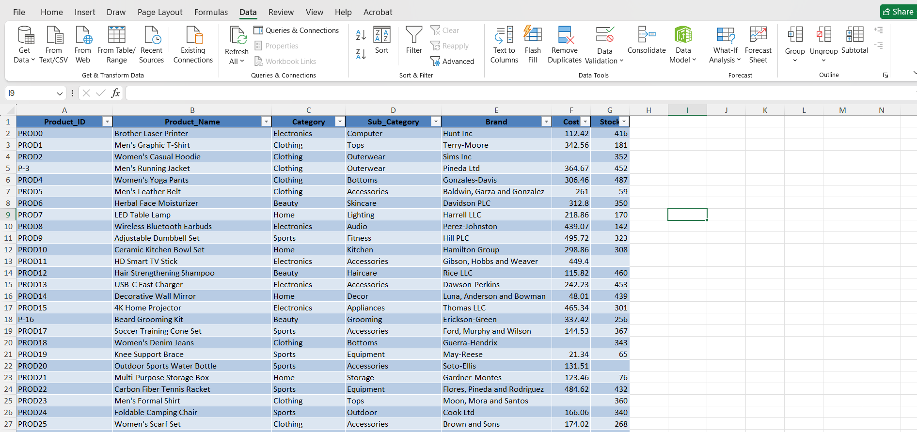

2)Data cleaning: find/remove duplicates, handle missing/inconsistent data, correct formatting errors, and validate data.
After selecting the datadata remove duplicates.
Missisng values is replaced by 0 in product,unknown in loyalty level and average in stock.
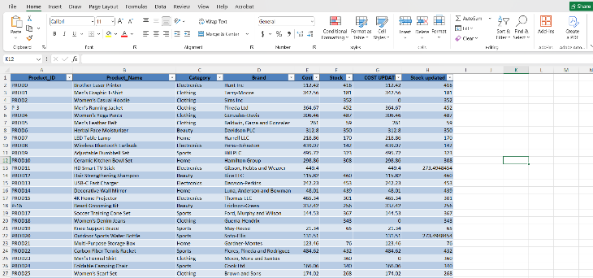

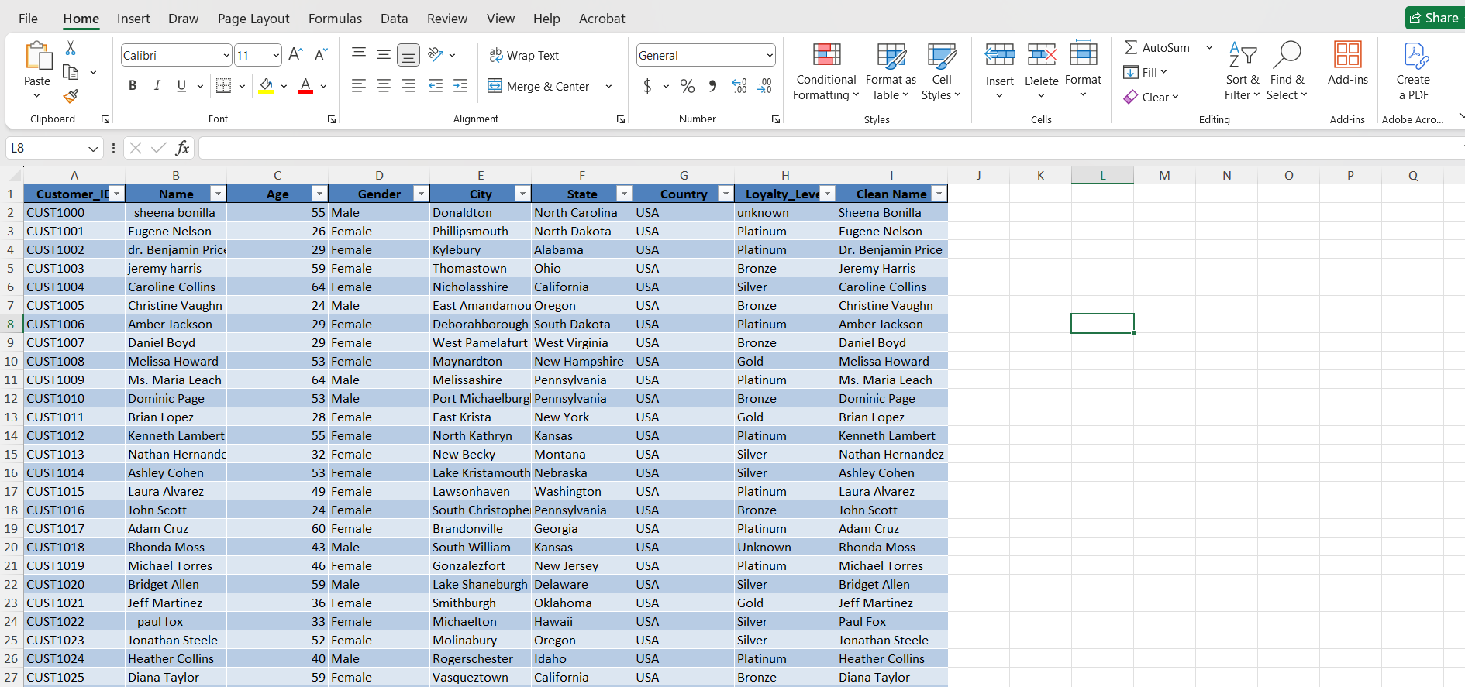
Application of Excel formulas for calculations, summaries, and logical/text operations
Gross Amount:- Quantity * Unit_Price
Net Amount:- Quantity * Unit_Price * (1 - Discount)
High Value Order;- =IF(Total_Amount > 500, "Yes", "No")

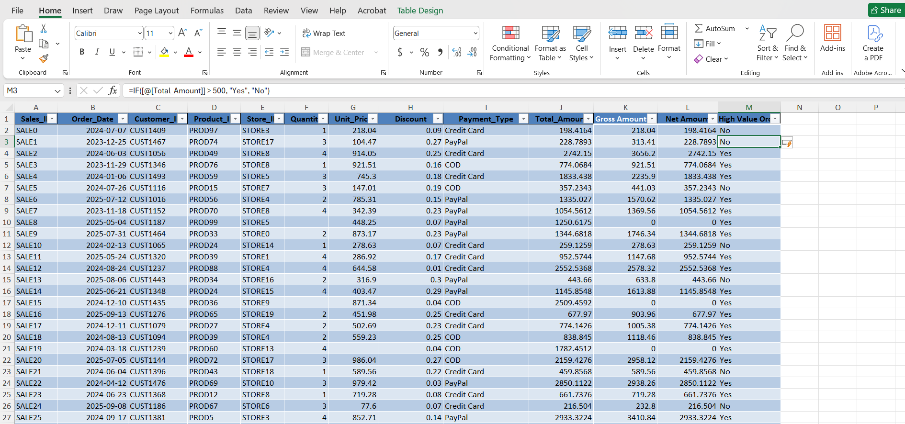

Use the XLOOKUP/VLOOKUP functions to combine the tables

